# Cloud Computing:

# Simply put, cloud computing is the delivery of computing services - including servers, storage, databases, networking - over the Internet (“the cloud”) to offer faster innovation and flexible resources.

# Key Characteristics of Cloud Computing:

# On-demand self-service:

# Customer can select the resources based on their needs and can upgrade/downgrade services at any time.

# Customers can access the resources at any time and from anywhere.

# Broad network access:

# Customers can access the resources over the internet from any geographical location.

# Resource pooling:

# Scale up/down based on the customer needs.

# achieve multi-tenancy

# Rapid elasticity:

# The resources can scale elastically with demand based on the consumer needs.

# Measured service:

# The resources used by the customer are done on a pay-per-use basis

# Resource usage can be monitored, controlled, and reported for both the provider and consumer of the utilized service.

# Architecture of Cloud Computing

Cloud Computing, which is one of the demanding technology of the current time and which is giving a new shape to every organization by providing on demand virtualized services/resources. Starting from small to medium and medium to large, every organization use cloud computing services in storing information and accessing that from anywhere and any time only with the help of internet.

Transparency, scalability, security and intelligent monitoring are some of the most important constraints which every cloud infrastructure should experience. Current research on other important constraints is helping cloud computing system to come up with new features and strategies with a great capability of providing more advanced cloud solutions.

**Cloud Computing Architecture:**  
The cloud architecture is divided into 2 parts i.e.

* Frontend
* Backend

The below figure represents an internal architectural view of cloud computing.

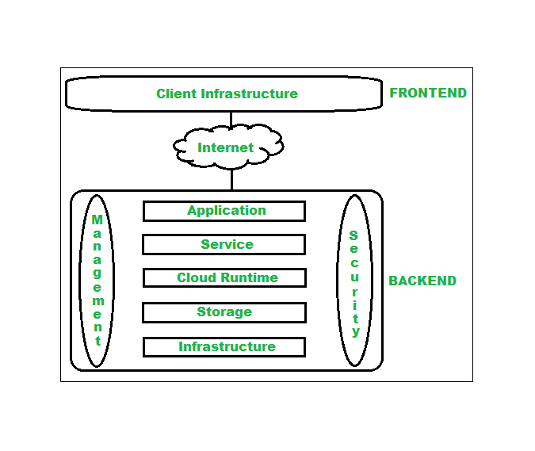

Architecture of cloud computing is the combination of both [SOA (Service Oriented Architecture)](https://www.geeksforgeeks.org/service-oriented-architecture/amp/) and EDA (Event Driven Architecture). Client infrastructure, application, service, runtime, storage, infrastructure, management and security all these are the components of cloud computing architecture.

**1. Frontend:**  
Frontend of the cloud architecture refers to the client side of cloud computing system. Means it contains all the user interfaces and applications which are used by the client to access the cloud computing services/resources. For example use of a web browser to access the cloud plat form.

* **Client Infrastructure –** Client Infrastructure refers to the frontend components. It contains the applications and user interfaces which are required to access the cloud platform.

**2. Backend:**  
Backend refers to the cloud itself which is used by the service provider. It contains the resources as well as manages the resources and provides security mechanisms. Along with this it includes huge storage, virtual applications, virtual machines, traffic control mechanisms, deployment models etc.

1. **Application –**  
   Application in backend refers to a software or platform to which client accesses. Means it provides the service in backend as per the client requirement.
2. **Service –**  
   Service in backend refers to the major three types of cloud-based services like [SaaS, PaaS and IaaS](https://www.geeksforgeeks.org/cloud-based-services/amp/). Also manages which type of service the user accesses.
3. **Cloud Runtime –**  
   Runtime cloud in backend refers to provide of execution and runtime platform/environment to the virtual machine.
4. **Storage –**  
   Storage in backend refers to provide flexible and scalable storage service and management of stored data.
5. **Infrastructure –**  
   Cloud Infrastructure in backend refers to hardware and software components of cloud like it includes servers, storage, network devices, virtualization software etc.
6. **Management –**  
   Management in backend refers to management of backend components like application, service, runtime cloud, storage, infrastructure, and other security mechanisms etc.
7. **Security –**  
   Security in backend refers to implementation of different security mechanisms in the backend for secure cloud resources, systems, files, and infrastructure to end-users.
8. **Internet –**  
   Internet connection acts as the medium or a bridge between frontend and backend and establishes the interaction and communication between frontend and backend.

**Benefits of Cloud Computing Architecture:**

* Makes overall cloud computing system simpler.
* Improves data processing requirements.
* Helps in providing high security.
* Makes it more modularized.
* Results better disaster recovery.
* Gives good user accessibility.
* Reduces IT operating costs.

**Services**

* 1. Saas
  2. Paas
  3. Iaas

**Saas**

* Owning software is very expensive. For example, a ₹50 lakh software running on a ₹1 lakh computer is a common place. Often the usage of a specific software package does not exceed a couple of hours of usage per week.
* In this situation, it would be economically worthwhile to pay per hour of usage. This would also free the user from the botherance of maintenance, upgradation, backup etc.
* As we can see, SaaS shifts “ownership” of a software from a customer to a service provider. Software owner provides maintenance, daily technical operation and support for the software.
* The service provider is a vendor who hosts the software and lets the users execute on-demand charges per usage units. It also shifts the responsibility for hardware and software management from customer to the provider. The cost of providing software services reduces as more and more subscribe to the service.
* It makes the software accessible to a large number of customers who cannot afford to purchase the software outright.

#### **Advantages of SaaS**

1. **Cost-Effective:** Pay only for what you use.
2. **Reduced time:** Users can run most SaaS apps directly from their web browser without needing to download and install any software. This reduces the time spent in installation and configuration and can reduce the issues that can get in the way of the software deployment.
3. **Accessibility:** We can Access app data from anywhere.
4. **Automatic updates:** Rather than purchasing new software, customers rely on a SaaS provider to automatically perform the updates.
5. **Scalability:**It allows the users to access the services and features on-demand.

**Paas**

* The capability provided to the consumer is to deploy onto the cloud infrastructure consumer-created or acquired applications created using programming languages, libraries, services, and tools supported by the provider.
* The consume r does not manage or control the underlying cloud infrastructure including network, servers, operating systems, or storage, but has control over the deployed applications and possibly configuration settings for the application-hosting environment.
* Example for paas services :
  + Heroku, Microsoft Azure, Google app engine, force.com, now-a-days firebase also
* Instead of ready-made applications or services, PaaS provides the platform for developing such applications and services.

**Advantages and Disadvantages:**

* You or your organization are responsible for the updating the software developed
* No need to provision servers. This is handled by the PaaS Cloud Provider.
* No need to manage the underlying data center. This is handled by the PaaS Cloud Provider.

**Iaas**

* The capability provided to the consumer is to provision processing, storage, networks, and other fundamental computing resources where the consumer is able to deploy and run arbitrary software, which can include operating systems and applications.
* The consumer does not manage or control the underlying cloud infrastructure but has control over operating systems, storage and deployed applications; and possibly limited control of select networking components (e.g., host firewalls).
* Example for Iaas services:
  + Amazon web services, Ec2

**Advantages and Disadvantages :**

* You or your organization are responsible for the versioning/upgrades of software developed
* Dynamic workload is supported
* It is flexible

# Difference between Cloud Computing and Grid Computing

**Cloud Computing:**   
Cloud Computing is a Client-server computing architecture. In cloud computing, resources are used in centralized pattern and cloud computing is a high accessible service. It is a pay and use business means, in cloud computing, the users pay for the use.

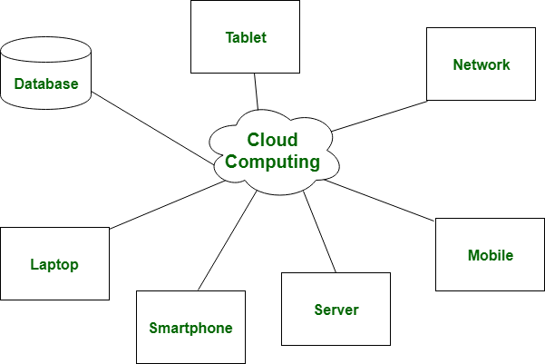

**Grid Computing:**   
Grid Computing is a Distributed computing architecture. In grid computing, resources are used in collaborative pattern, and also in grid computing, the users do not pay for use.

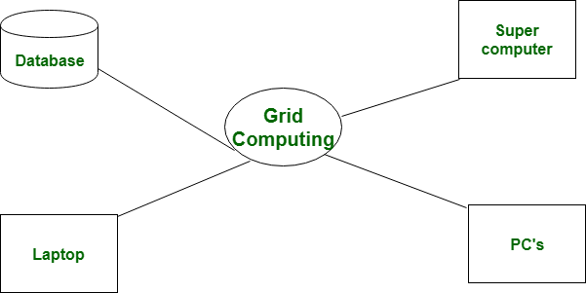

| S.NO | Cloud Computing | Grid Computing |
| --- | --- | --- |
| 1. | Cloud computing is a Client-server computing architecture. | While it is a Distributed computing architecture. |
| 2. | Cloud computing is a centralized executive. | While grid computing is a decentralized executive. |
| 3. | In cloud computing, resources are used in centralized pattern. | While in grid computing, resources are used in collaborative pattern. |
| 4. | It is more flexible than grid computing. | While it is less flexible than cloud computing. |
| 5. | In cloud computing, the users pay for the use. | While in grid computing, the users do not pay for use. |
| 6. | Cloud computing is a high accessible service. | While grid computing is a low accessible service. |
| 7. | It is highly scalable as compared to grid computing. | While grid computing is low scalable in comparison to cloud computing. |
| 8. | It can be accessed through standard web protocols. | While it is accessible through grid middleware. |

# Issues

## Security procedures

## Third party access issues

## Intellectual Property Rights

## Confidential data theft attacks

# 